Hello sir,

I was looking online for the installation of the magnet and the power supply, and it seems that there are a few steps.

Quick note, the common theme among hose sizes seems to be 3/8 inch. They mention that a lot of the fittings for the magnet wirings are gauge 4. Now Lakeshore sells wiring sets they say will be adequate to go to the magnet. I have included the part numbers for these sets at the end. So as far as electrical wiring for powering the magnet, I think we should pick the series wiring so that we’re guaranteed the same current.

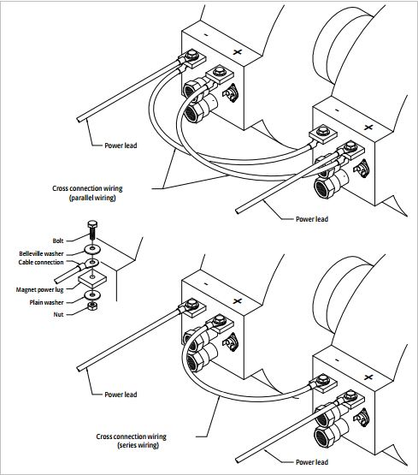

Sweet, so this wiring comes back to the magnet and attaches on the back panel.

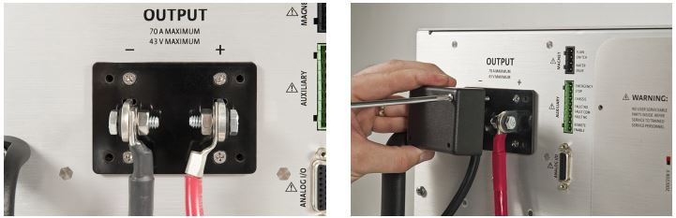

Cool, but there’s optional wiring on top of this, but more on this later, we can work around it but I highly recommend it.

So I would say the second step is to attach the wiring system. So in the documentation, they recommend screwing in hose barbs that adapt to 3/8 inch hosing that you hose clamp onto the barb. This picture attaching to the magnet does far better justice. Note the “to coil thermal interlocks” on the flow switch, additional degree of control.

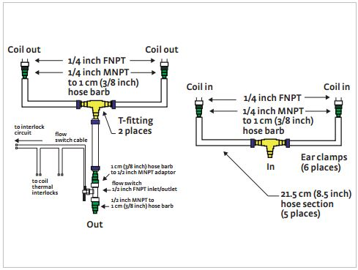

The hoses that attach to the magnet can be configured like this.

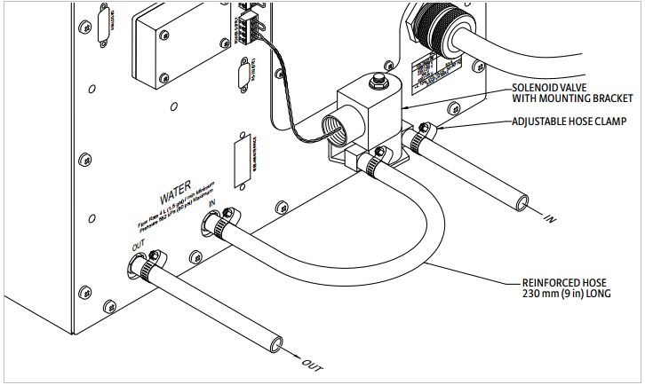

So what should probably happen is that the magnet and the power supply should both be fed from the same source and not use the out for the in on the other. Makes sense but I wanted to make that clear.

Final piece: in both pictures there is a flow switch on the magnet water supply (which the manual claims came with the magnet, bonus), and a solenoidal valve for the power supply, which we would have to order through them. Now this is not exclusive to the valve or the switch. The magnet can have both a valve and a flow switch, which is the most amount of control we can extend over it, or we can use just one or even none. This also goes for control over the power supplies water. What I would recommend is just getting flow switches for both the power supply and the magnet. This would turn off water until the machine is turned on, and as long as it’s on we’ll be at max cooling. If we have the valves in addition, it would allow us to control how much both are being cooled with the auto settings on the supply. Also, I don’t know if this is set at the wall or what, but the pressure across the both should be maintained at less than 80 PSI.

All the valve components are controlled electronically from the back panel of the power supply. These ports are Magnet connector and Power supply connector.

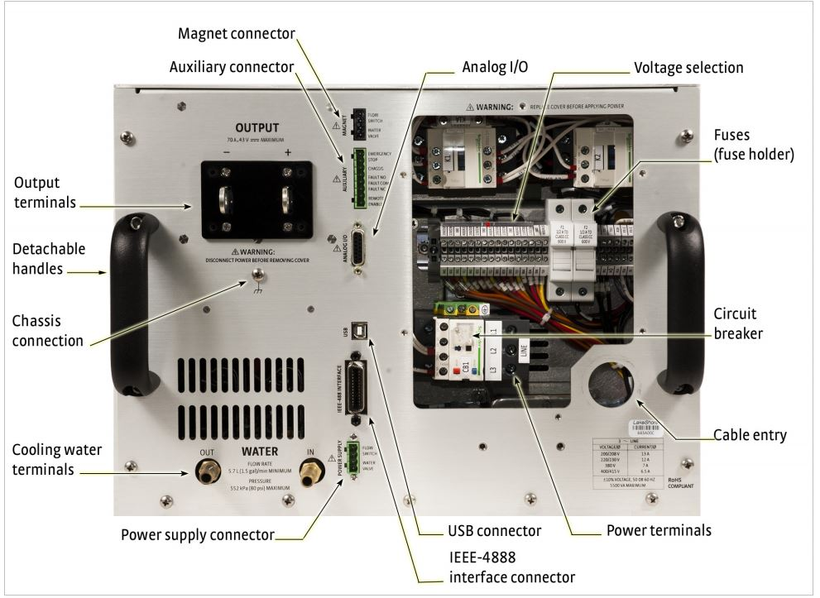

Like all functions that are available in the power supply, we should be able to control this all with serial control from our computer.

Parts I think we’ll need (preliminary):

|  |  |  |  |  |
| --- | --- | --- | --- | --- |
| Part | Part Number | Quantity | Critical? | Area of use |
| 3 m (10 ft) magnet cable kit, AWG 4t  OR  6 m (20 ft) magnet cable kit, AWG 4 | 6261-  Lakeshore product  6262 | 1 | Yes | This wires the power supply to the magnet, I would recommend going through Lakeshore on this. |
| Water flow switch | 6041 | 2? Or 1 if one came with the magnet. | I recommend it. | Simple on off feature that controls water flow to the magnet and power supply |
| Water valve | 6042 | 2, one for the magnet, one for the supply | Not entirely. Provides additional control and allows us to use the auto flow control feature. | Water supply control. |
| Reinforced Water hose, 3/8 inch. |  | Maybe 30 feet. This is my first rodeo, not sure how much we’ll need. | Yes | Water |
| T junction for water hoses. |  | 2 maybe four if we want to split water supply from the very start to both magnet and supply from one hose. | Yes | Attaches at the magnet to cool both coils. |